AMS588 HW#2

Siao Sun

Lulu Deng

Linna Hu

* The example: LR test and Wald test are 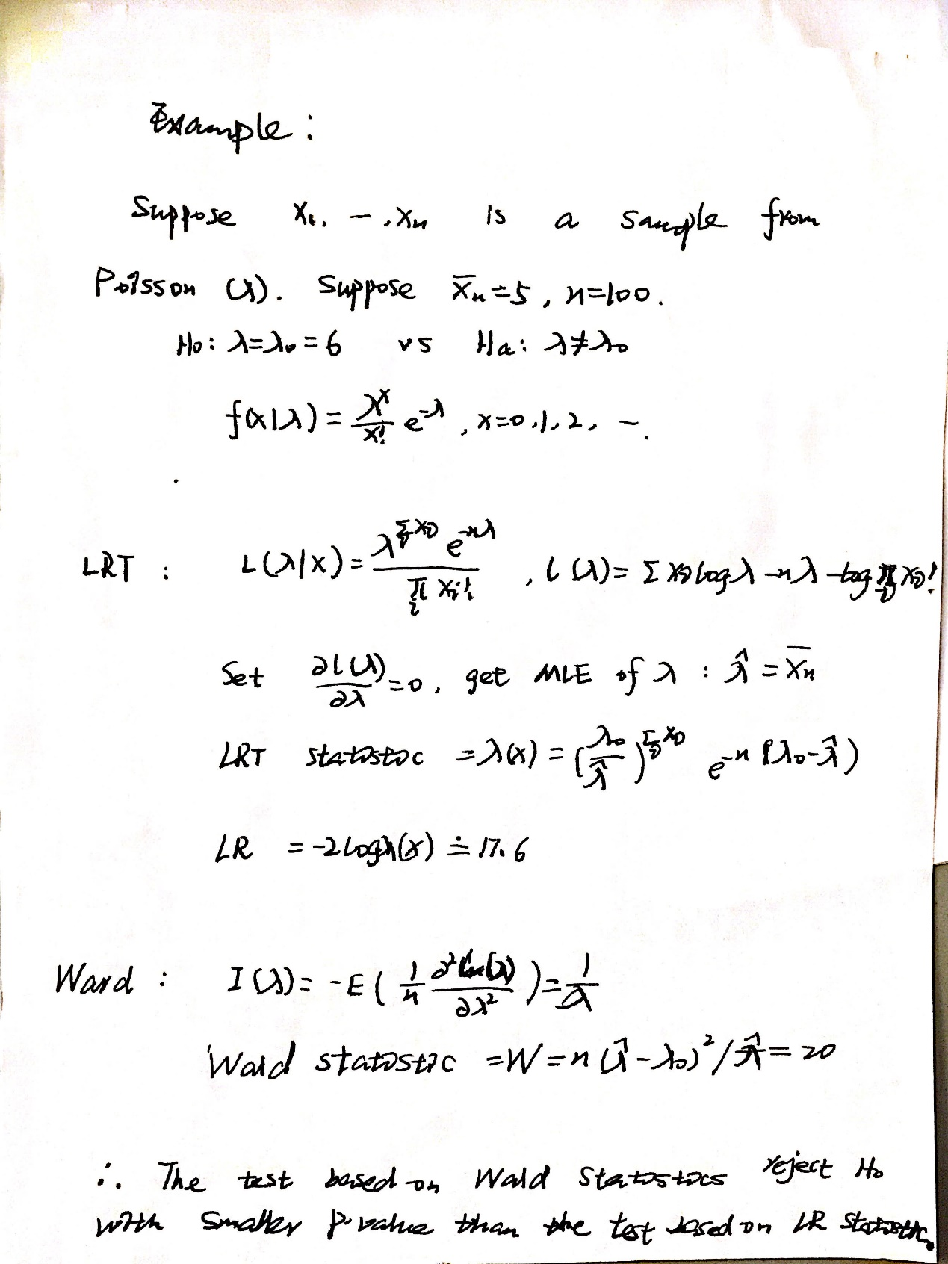not the same.

1. SAS

* Dataset

options ls=**120**;

**data** VALung;

drop check m;

retain Therapy Cell;

infile cards column=column;

length Check $ **1**;

label SurvTime='failure or censoring time'

Kps='karnofsky index'

DiagTime='months till randomization'

Age='age in years'

Prior='prior treatment?'

Cell='cell type'

Therapy='type of treatment'

Treatment='treatment indicator';

M=Column;

input Check $ @@;

if M>Column then M=**1**;

if Check='s'|Check='t' then input @M Therapy $ Cell $ ;

else input @M SurvTime Kps DiagTime Age Prior @@;

if SurvTime > **.**;

censor=(SurvTime<**0**);

SurvTime=abs(SurvTime);

Treatment=(Therapy='test');

datalines;

standard squamous

72 60 7 69 0 411 70 5 64 10 228 60 3 38 0 126 60 9 63 10

118 70 11 65 10 10 20 5 49 0 82 40 10 69 10 110 80 29 68 0

314 50 18 43 0 -100 70 6 70 0 42 60 4 81 0 8 40 58 63 10

144 30 4 63 0 -25 80 9 52 10 11 70 11 48 10

standard small

30 60 3 61 0 384 60 9 42 0 4 40 2 35 0 54 80 4 63 10

13 60 4 56 0 -123 40 3 55 0 -97 60 5 67 0 153 60 14 63 10

59 30 2 65 0 117 80 3 46 0 16 30 4 53 10 151 50 12 69 0

22 60 4 68 0 56 80 12 43 10 21 40 2 55 10 18 20 15 42 0

139 80 2 64 0 20 30 5 65 0 31 75 3 65 0 52 70 2 55 0

287 60 25 66 10 18 30 4 60 0 51 60 1 67 0 122 80 28 53 0

27 60 8 62 0 54 70 1 67 0 7 50 7 72 0 63 50 11 48 0

392 40 4 68 0 10 40 23 67 10

standard adeno

8 20 19 61 10 92 70 10 60 0 35 40 6 62 0 117 80 2 38 0

132 80 5 50 0 12 50 4 63 10 162 80 5 64 0 3 30 3 43 0

95 80 4 34 0

standard large

177 50 16 66 10 162 80 5 62 0 216 50 15 52 0 553 70 2 47 0

278 60 12 63 0 12 40 12 68 10 260 80 5 45 0 200 80 12 41 10

156 70 2 66 0 -182 90 2 62 0 143 90 8 60 0 105 80 11 66 0

103 80 5 38 0 250 70 8 53 10 100 60 13 37 10

test squamous

999 90 12 54 10 112 80 6 60 0 -87 80 3 48 0 -231 50 8 52 10

242 50 1 70 0 991 70 7 50 10 111 70 3 62 0 1 20 21 65 10

587 60 3 58 0 389 90 2 62 0 33 30 6 64 0 25 20 36 63 0

357 70 13 58 0 467 90 2 64 0 201 80 28 52 10 1 50 7 35 0

30 70 11 63 0 44 60 13 70 10 283 90 2 51 0 15 50 13 40 10

test small

25 30 2 69 0 -103 70 22 36 10 21 20 4 71 0 13 30 2 62 0

87 60 2 60 0 2 40 36 44 10 20 30 9 54 10 7 20 11 66 0

24 60 8 49 0 99 70 3 72 0 8 80 2 68 0 99 85 4 62 0

61 70 2 71 0 25 70 2 70 0 95 70 1 61 0 80 50 17 71 0

51 30 87 59 10 29 40 8 67 0

test adeno

24 40 2 60 0 18 40 5 69 10 -83 99 3 57 0 31 80 3 39 0

51 60 5 62 0 90 60 22 50 10 52 60 3 43 0 73 60 3 70 0

8 50 5 66 0 36 70 8 61 0 48 10 4 81 0 7 40 4 58 0

140 70 3 63 0 186 90 3 60 0 84 80 4 62 10 19 50 10 42 0

45 40 3 69 0 80 40 4 63 0

test large

52 60 4 45 0 164 70 15 68 10 19 30 4 39 10 53 60 12 66 0

15 30 5 63 0 43 60 11 49 10 340 80 10 64 10 133 75 1 65 0

111 60 5 64 0 231 70 18 67 10 378 80 4 65 0 49 30 3 37 0

;

* Proc phreg

**proc** **phreg** data=VALung;

class Prior(ref='no') Cell(ref='large') Therapy(ref='standard');

model Time*Status(**0**) = Kps Duration Age Cell Prior|Therapy / selection=backward

slstay=**0.1**;

**run**;

The use of the backward elimination process to identify the effects that affect the survivorship of the lung cancer patients.

* Results:

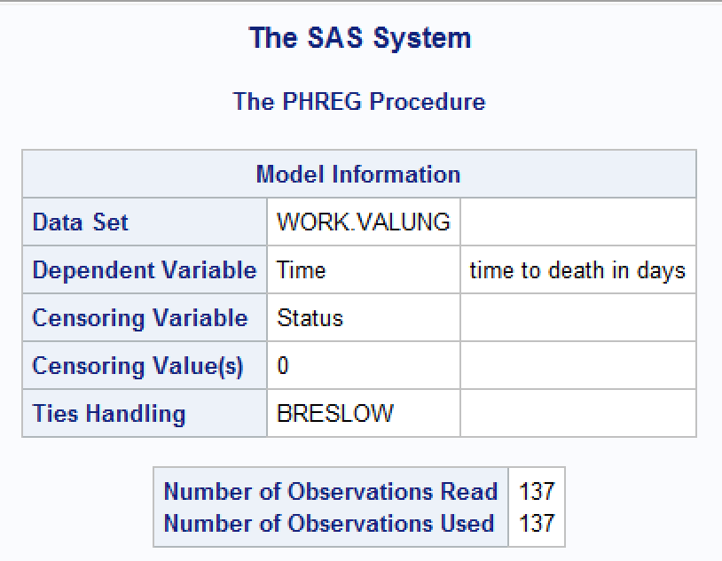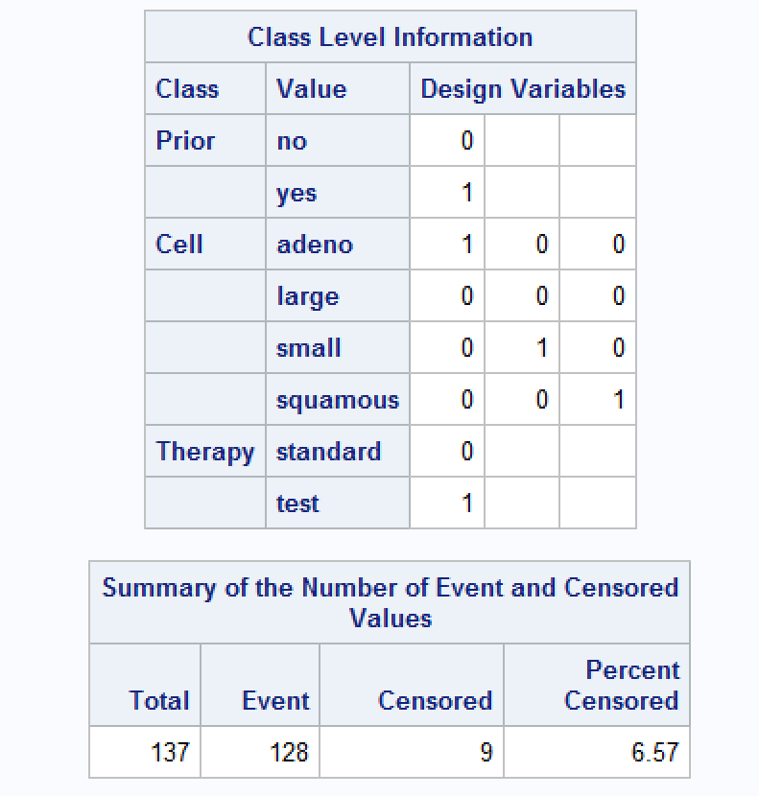

The variable has a value of 0 for the reference category (Prior=no, Therapy=standard).

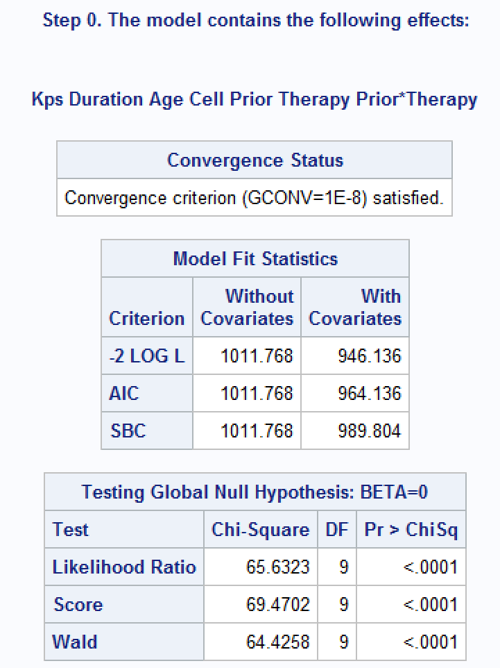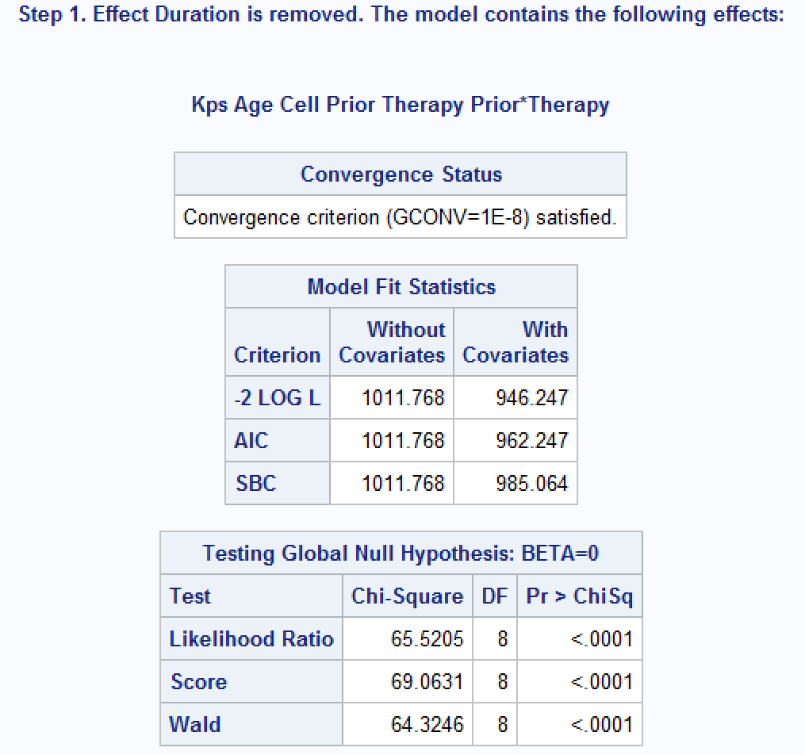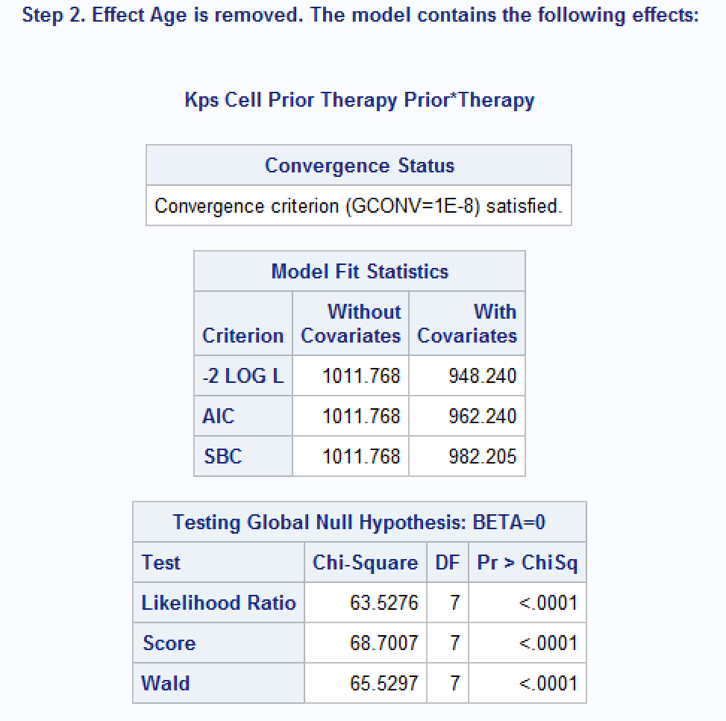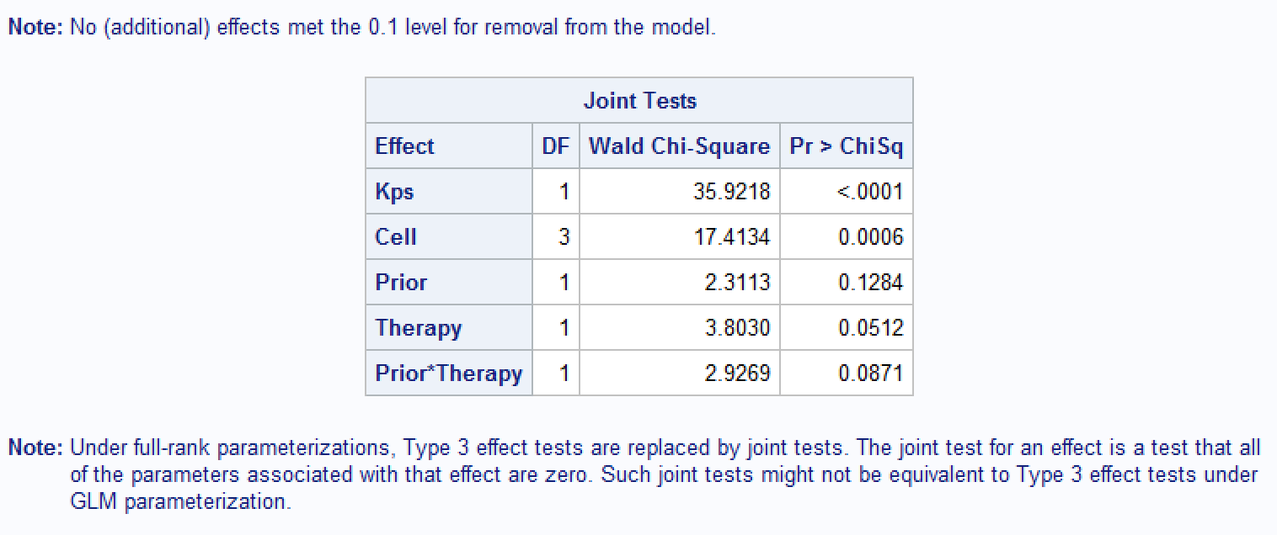

The effect Duration was eliminated first and was followed by Age.

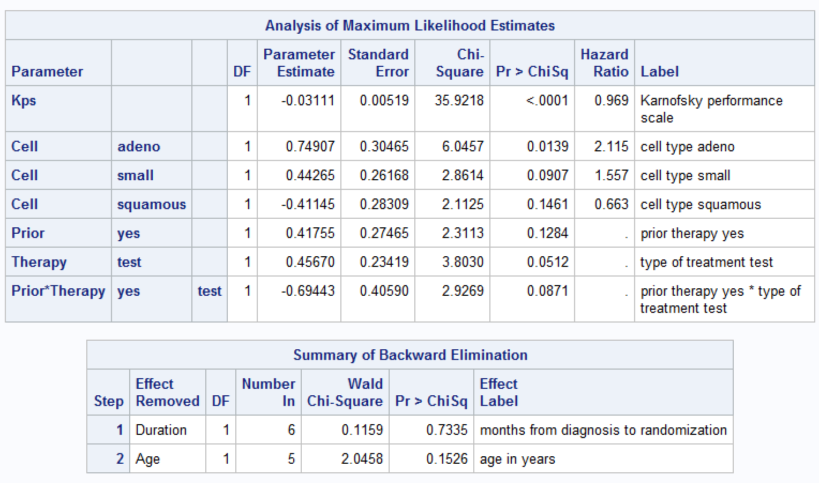

Without controlling for Age and Duration, KPS and Cell remain significant, but the Prior*Therapy interaction is less prominent than before (p=0.0871) though still significant at 0.1 level.

Also, we can use either the HAZARDRATIO statement or the CONTRAST statement to obtain hazard ratios.

**proc** **phreg** data=VALung;

class Prior(ref='no') Cell(ref='large') Therapy(ref='standard');

model Time*Status(**0**) = Kps Cell Prior|Therapy;

hazardratio 'H1' Kps / units=**10** cl=both;

hazardratio 'H2' Cell / cl=both;

hazardratio 'H3' Therapy / diff=ref cl=both;

contrast 'C1' Kps **10** / estimate=exp;

contrast 'C2' cell **1** **0** **0**, /* adeno vs large */

cell **1** -**1** **0**, /* adeno vs small */

cell **1** **0** -**1**, /* adeno vs squamous */

cell **0** -**1** **0**, /* large vs small */

cell **0** **0** -**1**, /* large vs Squamous */

cell **0** **1** -**1** /* small vs squamous */

/ estimate=exp;

contrast 'C3' Prior **0** Therapy **1** Prior*Therapy **0**,

Prior **0** Therapy **1** Prior*Therapy **1** / estimate=exp;

**run**;

Each has the CL=BOTH option to request both the Wald confidence limits and the profile-likelihood limits.

The DIFF=REF option specifies that each nonreference category is compared to the reference category. The purpose of using DIFF=REF here is to ensure that the hazard ratio is comparing the test therapy to the standard therapy instead of the other way around.

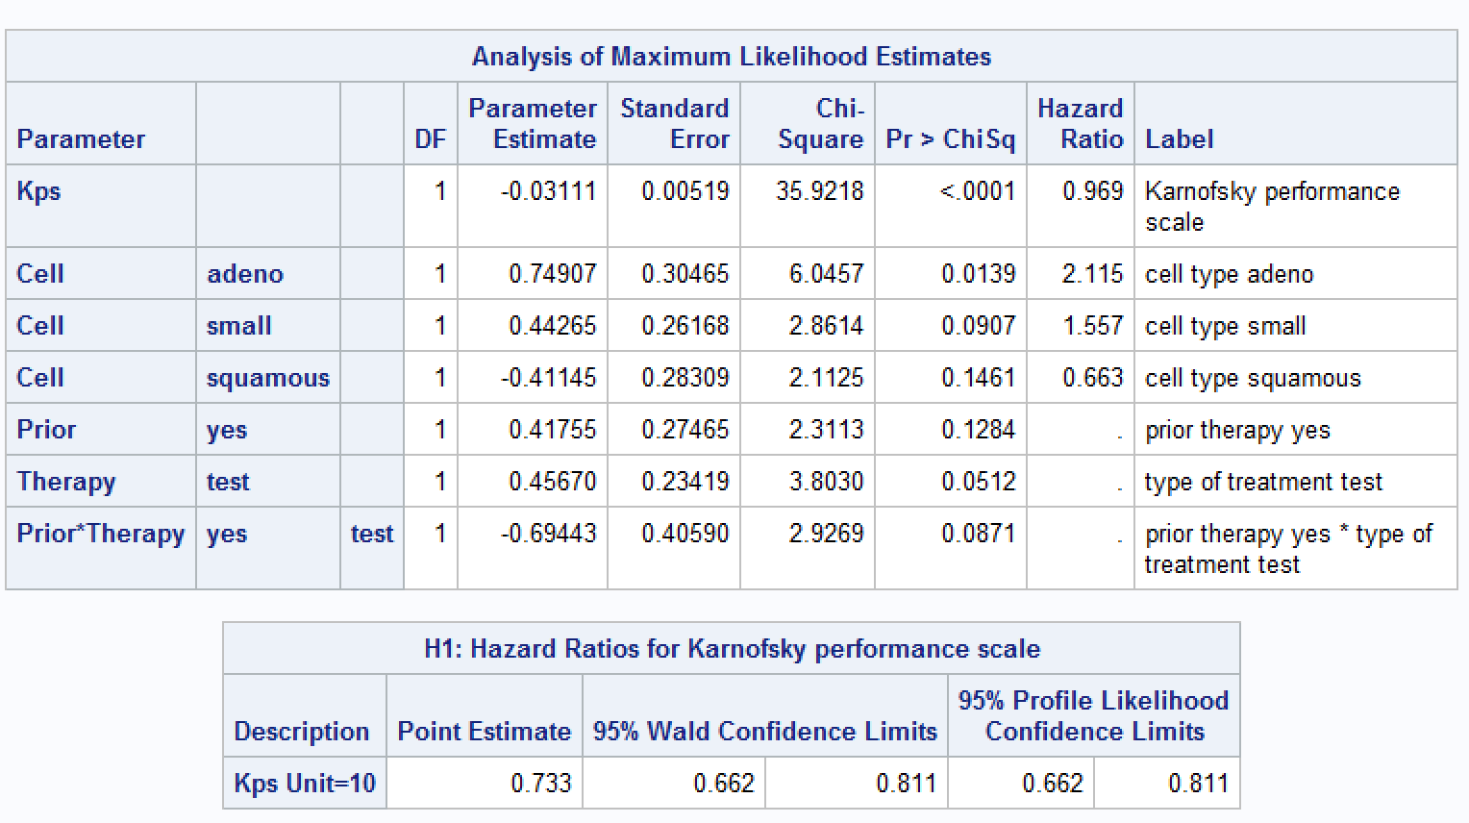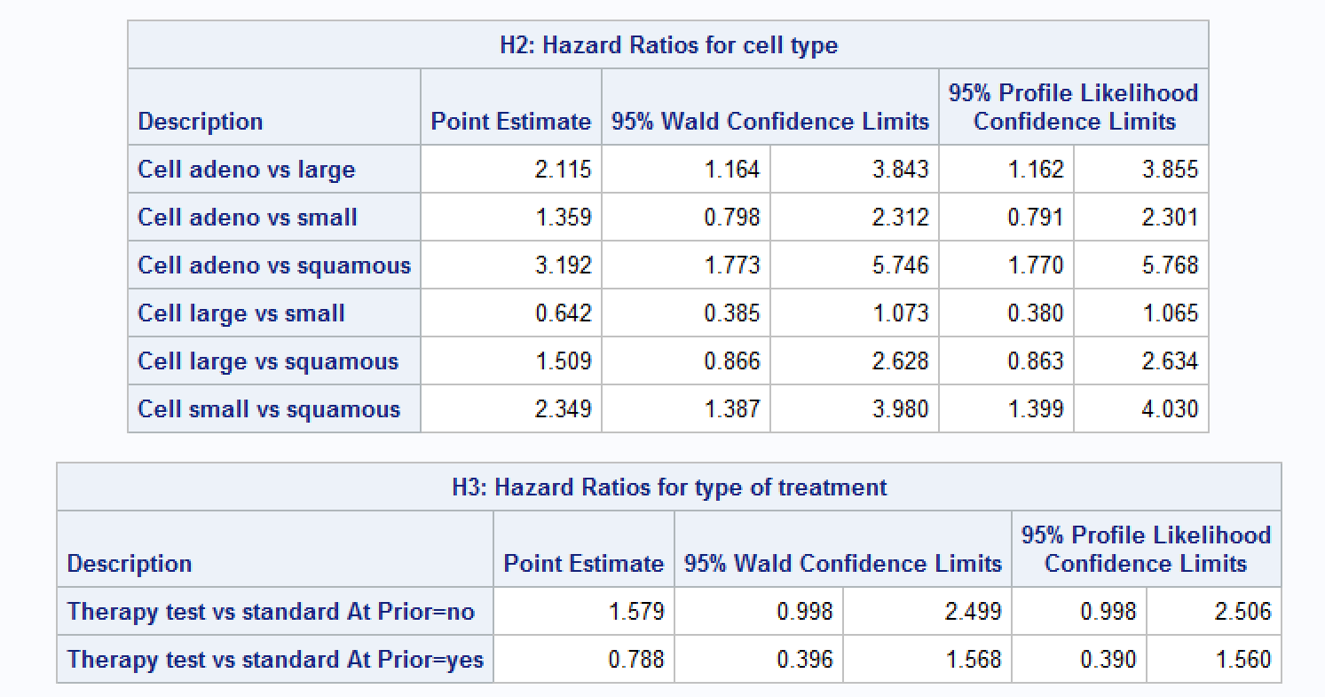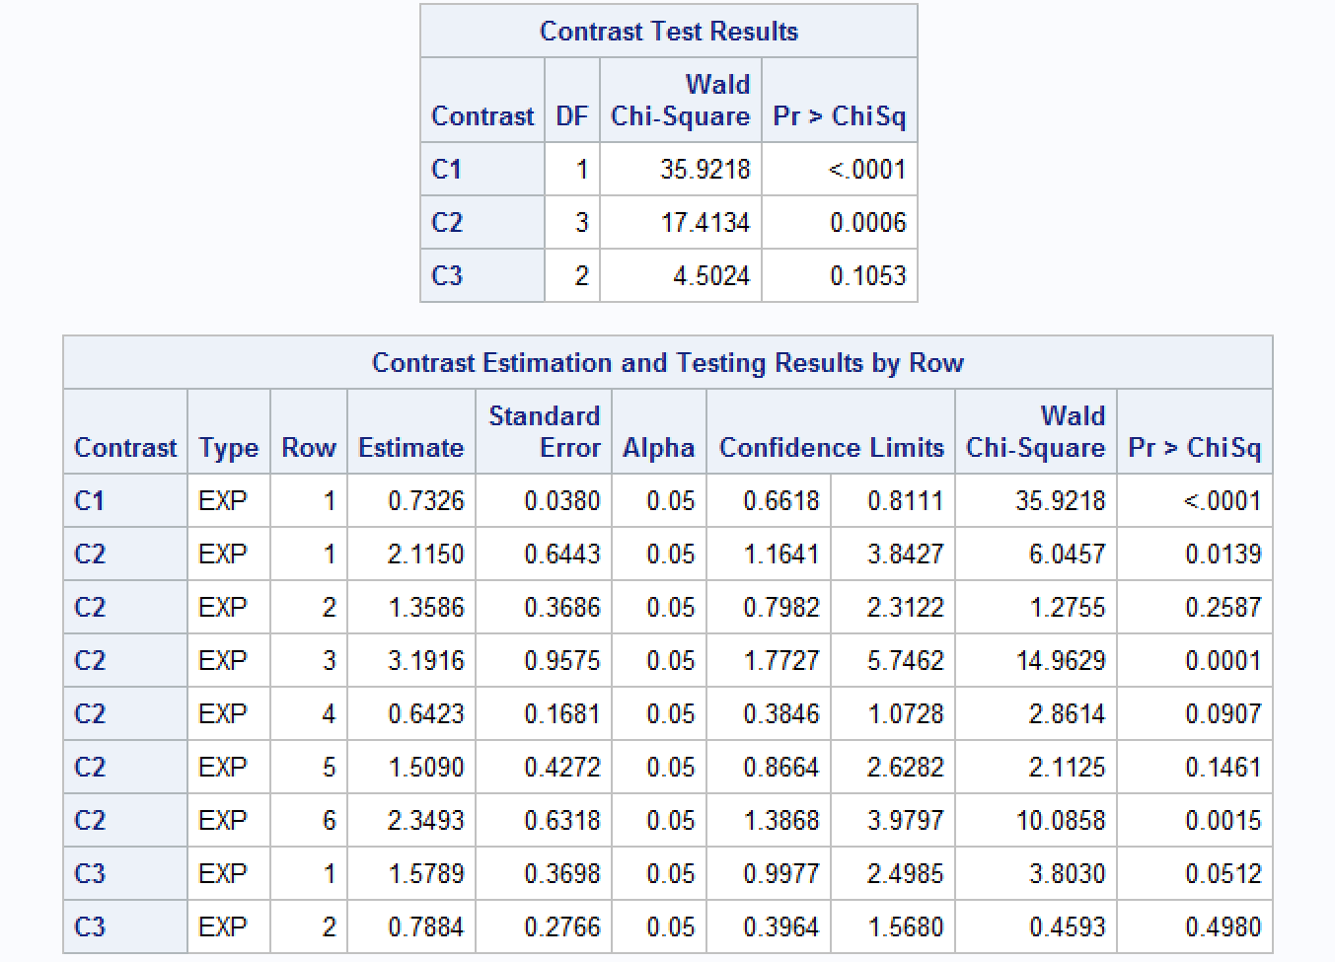

1. R

* Code

library(survival)

valung <- read.csv("C:/Users/Linna_hu/Desktop/Valung.csv", header = T)

fit <- coxph(Surv(Time, Status)~., data=valung)

fit

* Results

